### **TASK - 10: Setting Up the Project and Managing Dependencies**

#### **1. Create the Project and Activate the Virtual Environment**

1. **Navigate to the Project Directory**
2. **Activate the Virtual Environment**

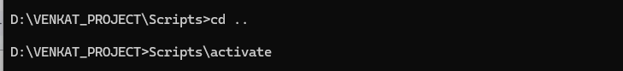

#### **Step 2: Install Required Python Packages**

1. **Install Flask, Requests, and NumPy Packages**

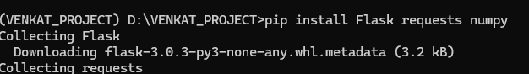

**2. Generate the requirements.txt File**

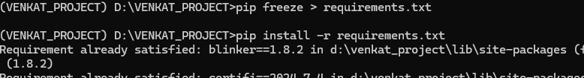

**3. Verify the Installed Packages**

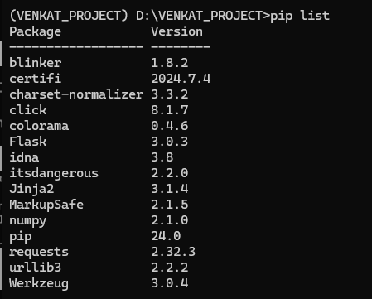

#### 

#### **2. Install a Specific Version of Flask (< 2.0)**

1. **Install Flask Version 1.1.4**

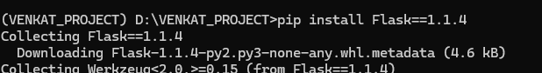

**2. Verify the Installed Version of Flask**

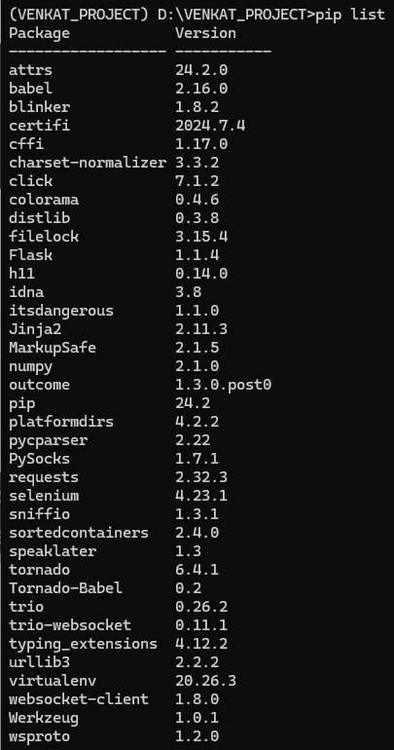



#### **Attach the requirements.txt File**

The requirements.txt file has been attached and is available in the GitHub repository. You can access it at the following link:

**GitHub Repository**:: <https://github.com/ragulVenkat/Guvi-Task-10>